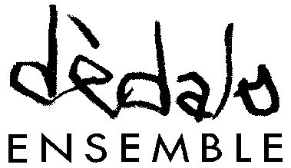

Composition and Orchestration Masterclass
Mauro Bonifacio • dèdalo ensemble

March 2026 - October 2026

Application Form

The undersigned __________________________________________________________________

Born in ____________________________________________________________________________

on __________________________________________________________________________

Address __________________________________________________________________________

Citizenship _________________________________________________________________________

REQUESTS

admission to the Composition and Orchestration Masterclass as

student auditor

Please attach:
1. 2 scores in PDF format for different ensembles;
2. CV;
3. Copy of an identity document;
4. Copy of tax ID code;
5. Receipt of payment of the admission fee: €50.00.

Complete documentation should be sent by email to info@dedaloensemble.it

Place Date

